**LAPORAN GRAFIKA KOMPUTER**

# **PERTEMUAN 3**

**Yudha Ginong Pratidina**

**21104410001**

**TI-4A**

**PRAKTIK 01 – BACKGROUND**

<html>

<head>

    <title>Praktek 1 - Background</title>

</head>

<body>

*<!-- CDN P5JS -->*

<script src="https://cdnjs.cloudflare.com/ajax/libs/p5.js/1.6.0/p5.min.js" integrity="sha512-3RlxD1bW34eFKPwj9gUXEWtdSMC59QqIqHnD8O/NoTwSJhgxRizdcFVQhUMFyTp5RwLTDL0Lbcqtl8b7bFAzog==" crossorigin="anonymous" referrerpolicy="no-referrer"></script>

*<!-- CODE -->*

<script>

    function setup() {

        createCanvas(200,200);

    }

    function draw(){

        background(0);

    }

</script>

</body>

</html>

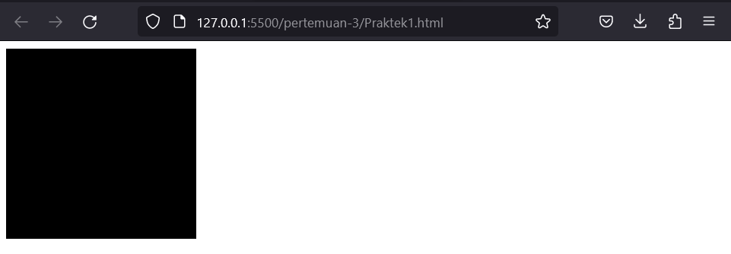

**PRAKTIK 02 – Background RGB**

<html>

<head>

    <title>Praktek 2 - Background RGB</title>

</head>

<body>

*<!-- CDN P5JS -->*

<script src="https://cdnjs.cloudflare.com/ajax/libs/p5.js/1.6.0/p5.min.js" integrity="sha512-3RlxD1bW34eFKPwj9gUXEWtdSMC59QqIqHnD8O/NoTwSJhgxRizdcFVQhUMFyTp5RwLTDL0Lbcqtl8b7bFAzog==" crossorigin="anonymous" referrerpolicy="no-referrer"></script>

*<!-- CODE -->*

<script>

    function setup() {

        createCanvas(200,200);

    }

    function draw(){

        background(252, 61, 224);

    }

</script>

</body>

</html>

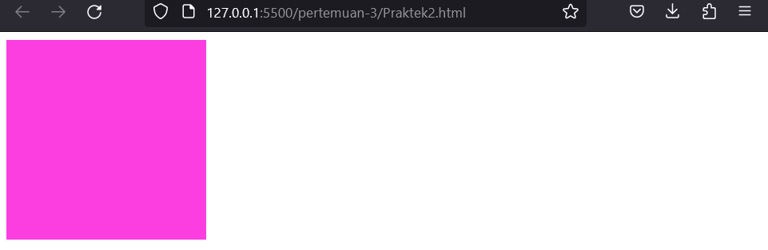

**PRAKTIK 03 – Fill**

<html>

<head>

    <title>Praktek 3 - Fill</title>

</head>

<body>

*<!-- CDN P5JS -->*

<script src="https://cdnjs.cloudflare.com/ajax/libs/p5.js/1.6.0/p5.min.js" integrity="sha512-3RlxD1bW34eFKPwj9gUXEWtdSMC59QqIqHnD8O/NoTwSJhgxRizdcFVQhUMFyTp5RwLTDL0Lbcqtl8b7bFAzog==" crossorigin="anonymous" referrerpolicy="no-referrer"></script>

*<!-- CODE -->*

<script>

    function setup() {

        createCanvas(200,200);

    }

    function draw(){

        background(220);

        fill(255,255,0);

        circle(100,100,50)

    }

</script>

</body>

</html>

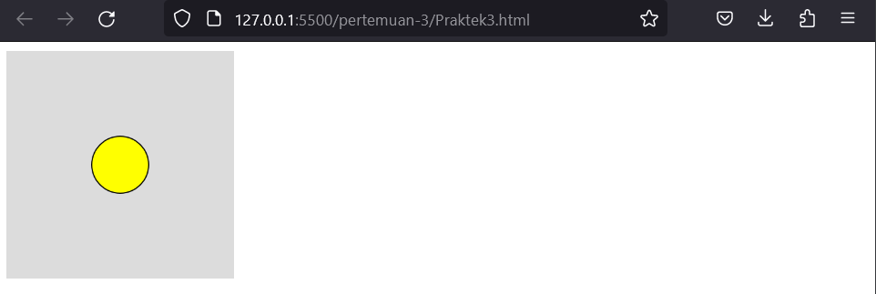

**PRAKTIK 04 – Fill beberapa Object**

<html>

<head>

    <title>Praktek 4 - Fill beberapa object</title>

</head>

<body>

*<!-- CDN P5JS -->*

<script src="https://cdnjs.cloudflare.com/ajax/libs/p5.js/1.6.0/p5.min.js" integrity="sha512-3RlxD1bW34eFKPwj9gUXEWtdSMC59QqIqHnD8O/NoTwSJhgxRizdcFVQhUMFyTp5RwLTDL0Lbcqtl8b7bFAzog==" crossorigin="anonymous" referrerpolicy="no-referrer"></script>

*<!-- CODE -->*

<script>

    function setup() {

        createCanvas(200,200);

    }

    function draw(){

        background(220);

        fill(255,255,0);

        circle(100,100,50);

        rect(0,0,100,50);

        eclipse(50,70,30,30)

    }

</script>

</body>

</html>

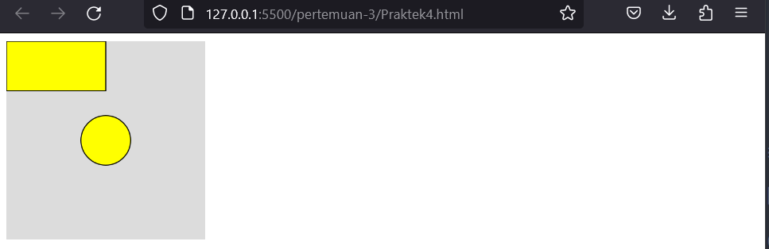

**PRAKTIK 05 – No Fill**

<html>

  <head>

    <title>Praktek 5 - No fill</title>

  </head>

  <body>

*<!-- CDN P5JS -->*

    <script src="https://cdnjs.cloudflare.com/ajax/libs/p5.js/1.6.0/p5.min.js" integrity="sha512-3RlxD1bW34eFKPwj9gUXEWtdSMC59QqIqHnD8O/NoTwSJhgxRizdcFVQhUMFyTp5RwLTDL0Lbcqtl8b7bFAzog==" crossorigin="anonymous" referrerpolicy="no-referrer"></script>

*<!-- CODE -->*

    <script>

      function setup() {

        createCanvas(200, 200);

      }

      function draw() {

        background(220);

        fill(255, 255, 0);

        circle(100, 100, 50);

        rect(0, 0, 100, 50);

        noFill();

        ellipse(50, 70, 30, 30);

      }

    </script>

  </body>

</html>

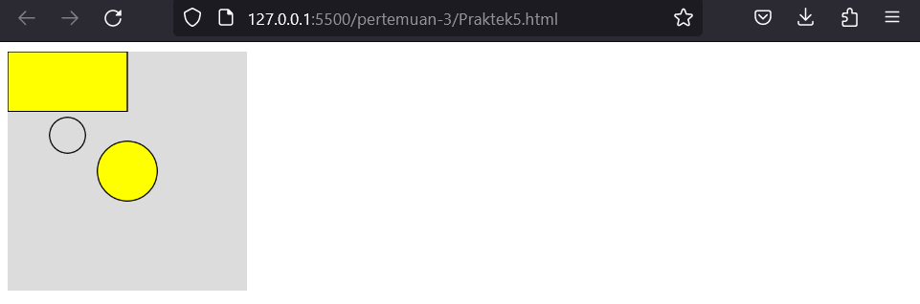

**PRAKTIK 06 – No Fill Transparant**

<html>

  <head>

    <title>Praktek 6 - No fill Transparant</title>

  </head>

  <body>

*<!-- CDN P5JS -->*

    <script src="https://cdnjs.cloudflare.com/ajax/libs/p5.js/1.6.0/p5.min.js" integrity="sha512-3RlxD1bW34eFKPwj9gUXEWtdSMC59QqIqHnD8O/NoTwSJhgxRizdcFVQhUMFyTp5RwLTDL0Lbcqtl8b7bFAzog==" crossorigin="anonymous" referrerpolicy="no-referrer"></script>

*<!-- CODE -->*

    <script>

      function setup() {

        createCanvas(200, 200);

      }

      function draw() {

        background(220);

        fill(255, 255, 0, 50);

        circle(100, 100, 50);

        rect(0, 0, 100, 50);

        noFill();

        ellipse(50, 70, 30, 30);

      }

    </script>

  </body>

</html>

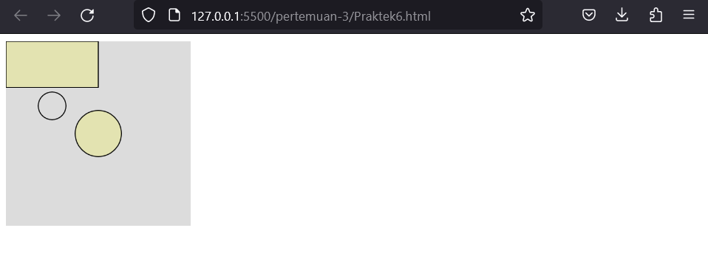

**PRAKTIK 07**

<html>

  <head>

    <title>Praktek 6 - No fill Transparant</title>

  </head>

  <body>

*<!-- CDN P5JS -->*

    <script src="https://cdnjs.cloudflare.com/ajax/libs/p5.js/1.6.0/p5.min.js" integrity="sha512-3RlxD1bW34eFKPwj9gUXEWtdSMC59QqIqHnD8O/NoTwSJhgxRizdcFVQhUMFyTp5RwLTDL0Lbcqtl8b7bFAzog==" crossorigin="anonymous" referrerpolicy="no-referrer"></script>

*<!-- CODE -->*

    <script>

      function setup() {

        createCanvas(200, 200);

      }

      function draw() {

        background(220);

        fill(255, 255, 0, 50);

*// Garis Hijau*

        stroke(0, 255, 0);

        circle(100, 100, 50);

*// Garis Merah*

        stroke(255, 0, 0);

        rect(0, 0, 100, 50);

        noFill();

*// Garis Biru*

        stroke(0, 0, 255);

        ellipse(50, 70, 30, 30);

      }

      function setup() {

        createCanvas(200, 200);

      }

      function draw() {

        background(220);

        fill(255, 255, 0, 50);

*// Garis Hijau*

        stroke(0, 255, 0);

        circle(100, 100, 50);

*// Garis Merah*

        stroke(255, 0, 0);

        rect(0, 0, 100, 50);

        noFill();

*// Garis Biru*

        stroke(0, 0, 255);

        ellipse(50, 70, 30, 30);

*// Tanpa Garis*

        noStroke();

        fill(255, 255, 0);

        circle(20, 180, 50);

      }

    </script>

  </body>

</html>

